:_-
EGli-6
FEn'r rgs
_{{4$riir,} ^{qrdl{r} t}' ::iq naErd{i ard(r! fd$r1
crl6qa
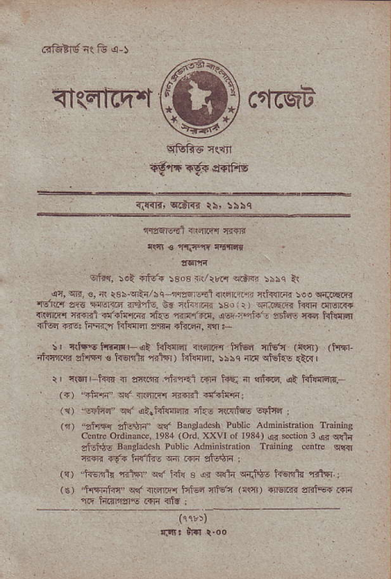
^{:rfi.'litrrll {Errr} :
oti{, 5ot o6! 5eos _{{Vrrn} ^{q.tE} iilq ir
_{{n} ^{qif,} €, { _{t35} ^{qE{/iqjim..i1} itar41r _{iti{d.nr :e!} qqiq.R ^{trdr.'r} zlt aturir-f rirlc, Er nihlm 59 _{r ir)} ^{q.ftFF{} i?I{ r{ctFr {rrF F64 {f{FrE ^{'i}} _{I} ^{r.affi,} _{oor} r*- , _{!r?s} ^{Fdd} F @'Ir {iG rrE: he.J tEil@ dm rft@, w !-
s, _{{16 tr.irlF{t hftr@ {@rr{ iii6} qffq (d!{r) (irrr _{ntrq,rqi} ^{ql.Isq} € Fr€ntu rrltr) tri{rR, !s\c il.{ ^{qi6t{E} €& | I ctd,-krr { anlfttl.riffi.i iirq t$q _{n} ^{qtri6,} <i idln@R,
^{(r)} _{"Edtq'q(} ^{qirtdlqq&} _{rhE rri{rtuE} ^{$5fndr} l
^{(r)} _{"rtr{r dsSrn} ^{qt'} Bansradcsn ?dic Adninntaiiotr Tditrins _{csirc ordinan@, 1931} (orJ. xxvl ol le34) qi ^{s'jon 3} {r sra{ _{effigE} Bmgradsh Ptrbric Adnini
&R .9'{ ftft'rirE w m ljiqn :
^{'i,} h. _{'t} ^{-d"q} fr ft s fdi 4r:r9= 5q5tr {rtq.: _{(€)} ^{,.il.ldlTc., qd} _{{tzi@ Ftuq {€'c} ^{(c.fi)} {Mrn a<i5F m ^{qt'} inrlft iqln 4if i
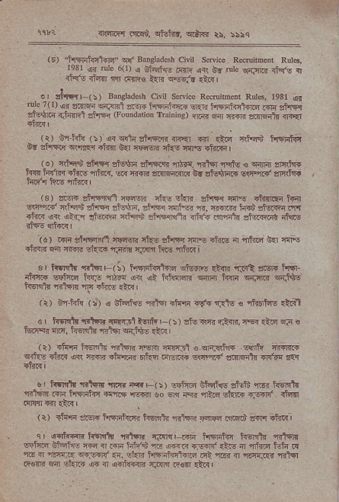
_{Tflri.fl rrr6n,} qfuJ3Rt, ^{q.:r+.r} rs, :;bq
⁽⁶⁾ _{tfiilirt@"} ^{qlf} Bdekdcsh civn seNne Reflibeoi Rul6! r-o3 .{ _{u"} ^{q" 1€!.6.a.} rfli d. _{,i} rure €'zii r.rE i {R- <r4n nll ^{ir{Fo} _{l{F} ^{q6ei.} _{.46} j
^{., d*n,} _{r"t} sansladcsn civil scdce Rsruibmr _{Rd6, resr} qil ^{ore 7( 1)} en zi{Ea ffFRi ofti.r _{t$ni3r.{} ^{q{R} hFFfonar.{ .{r ?itrFi di-tur {.ti{rd anFFr aFdoda'ion ^{rmidjs)} !R fl ffi a?{lFrt il3<r
(r) B{hto (5) ^{qr q{i{} sflFNf{ dr.qr ^{iFjr} *cr *ffi hsT{irt _{6d z?Rr} ^{qt'llrq} +ji{ 0{ r€{crj d.s arE *.r" I
(e) c1t5'n sftT{ adE st{rrr rds. rdrsl nqtu € cmi $ftnr+ rrF h'frr af<s rh<, w ry{ri !1r,q\r11.( br _{atu$Ei+} ^{q1-nf} erjr(tf{
⁽³⁾ siw ciqF{l rarq cl.G d.R _{i*%q} ^{qfl€} rfr{t!" trn slPr.C a}FS snFr sBF, afa'Fr c{rn!- r. ffi _{ilF":} gftaftir'rT _{+tur o(} ^{q?..} dffi ltffi d4rftft. {ff{ Fpnlc daF6i drs
(a) trJlq eftFi,R :Ef6r4 ifts an1qr rllE +irc ^{ar} _{"rd{a ori} q{p! +i€ri e_r\ {triR 6r'{F r.T{{ riF ftF atlr{i
sr Mr.filwr ^{(:)} _{ffiri} ^{qtu"ird:t-{r} rilt si5i ^{t{.{r} irii!+ _{eaiiri hw d"a o{} ^{qi} hnqaE lmFr _{hqrn} ^{qaF.r} FJ$s hsDlr rntrr rF al;e !:.r
(r) fi'ftf{ ^{(!) q} BlFrl€ rili alffr <f{ '3le € rliirhF ri6r
d' ftE 1{rtl-F @-E1tr' (!,r,?ft+n ffir>.dd.a€ rqrqr {rd, hqdq _{rllsr} q{jg5.Ai,
(r) itui" _{kErii{ Elfil} ^{qqiJ} _{rqrd c} qra.!\li{ ltllh ^{irrsir' qrh!} dfi s{ rF. its.iR mful FlrtrrqF s(I.nrez anmdi Ts<dr lar
!, ffi {r}flc nmr<rF(i) E$hd tH@ ^{Etri izr{ ffi 'r.1@} .rF trflrJir ?rq.{ {-ql oo 6r rE" {:zq sft.+ qE<d rid{ r<lfr r& c1'.{ |
^{(r)} lilF dF { Mrlnr ffi rrlF.i ilnaa _{o@i ir€.I rkr{} | ^{qr} Fn!ffi t@T r':q rrarr _{m} ^{r4nin} fi. rlr €f-n iff{ @ _{r} .fi ^{%e-,EF.@,tEr} ffi t.iiF _{m d rlnri.} ^{q{F.|t'} rr, Ei.jr _{li6{h1ffi F:} ^{.m} _{n} ^{,rnri1r} {r1,'] Ii€ft ria sfuF a. { oFd{.nr cr{rr tuT ri.<j
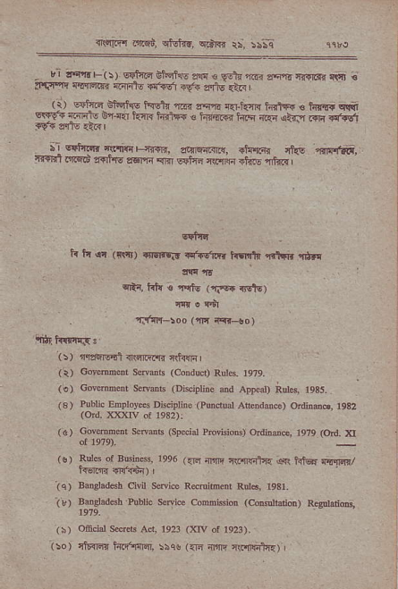
,l r.{n!' ^{(s,} eq 6tr6 ?rtr º Vdr @ _{cqn} ^{rf{r'd} {!a € t'ri.t cEm.{r mnto n?vr rV+ rns rrti I
( I ste ^{6ll:ch!} _{ic61p} ^{qa{} _{Fii e} .h'i. ^{hrr'{d} _{c hFa!} q!( ^{srr.} _{rrl,} ^{gl.q} _{li.'r.} ^{.4rF+} € l4{F ^{e.+} _{ri'i} ^{jtrr} ."8 d.sl 9E{ fiE €i{l
^{ji 6stan? 'a!{qF{r{F.} a!!''€-j?{nr. ^{.t'rft:-r ,iI! i,r..n!.} tirrrl .!Fd erFfitls _{zrom} ^{qRr} sFlfi r|t nq elr6 rtr& |
6{ttr
tr _{l:l} qr ({vr) ^{glsrrEi'} n.snTj ir.rile rit*. {}F
^{qE:{,} _{trto e} 'F,!t6 ^{(rF.} il't6)
fllovdt
. Tlsfr-lod (.iFr i< !o)
(r, 'qrf.zl .FFr,lr Jnh{rrl
(q) Gqe@hr scrorr (condlco Rnl4. re7e.
sensB rDj.'otjne and App(3lr RdF ra35.
(3) ?ubric EDproFes Dkcipthe ^{(putuot} Aftrdm€) ^{odindo, 1932 (ord} l?XIv ol 1932): (6) Govedn.nt s€nba ^{(sp@i,l} rrdniodq ordiru€, t9?9 ^{(ord.} )(I
rs) RulB oI Bairdt .oe6 ^{,ft} {E _{rc@t'r} ^{.q} _{iitR} qii?E/
_{iq)} Baosladdh civil swica R€mih.rl Rui6, 1931-
(3) Baogtad6! Public senie comisrtor ^{(cmsndi@)} Rrsddli@,
(h) ^{nficiar} _{ser.r5 Aci, 1923} ^{(l<w} of 1923).
Go ) rlfidn lnirr,Ftqr, \rq! (atr ltr ₁₁ qrinhz)
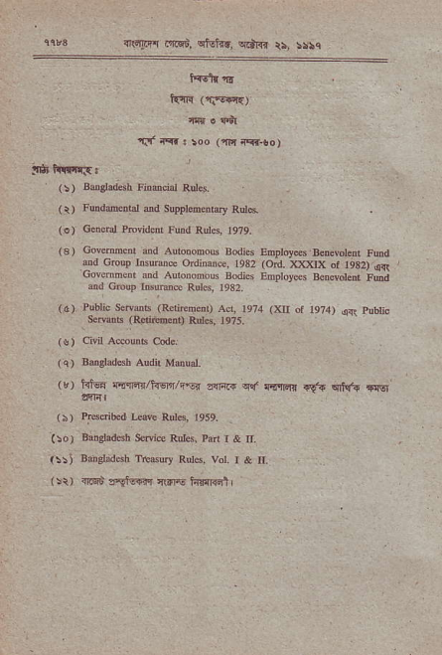
rYF. l'@n. wEi.r, ^{odrd} r:. sr5c
^{''if} -q. . _{roo} ^{('ftr} rr<r.co)
(!) sugl.desh li'eciar tunei.
(t) Fuducnral ^{ad supptoocnrary} Rrn*
(o) G.ncd rrovidcnt Fuod Rulcs, 1979,
(s) covdnftcnt d Anroromous Bodies Employes Bdevorm! fuld dd cronp ^{tnsuranq onliiaoe,} ₁₉₃₂ ^{(od.} )ooqx ^{of 1932)} !!{r Bodj., Enproyes BdevoLni Frud
&d crcup rnsElne Ruts, 1932
(!) Pubric s.ieB ^{(Reln.mcit} Ad, te74 ^{(xu} or 1974) _{q<t} pubric . s.nmr ^{(Rdjddcd)} Rur6, 1e7s.
(!) civn aeoua c.de.
(q) aodads$ Audir MmuaL
^{,k'} rdd ^{cli'@ tcEi} _{"br} 3FF !{ ^{@Fm} _{"9..} ^{qFra} !s (i) P:lsdibed L@ Rul6, lese,
(\o) Ba'srd6h s.ni.e Rd.s, Pld 1 & n.
(::j Baoslsd6h f(aUry R!ls, vot. I & rI
⁽ !r) {Fn c-i-€n lrr|6 h.{rdl L
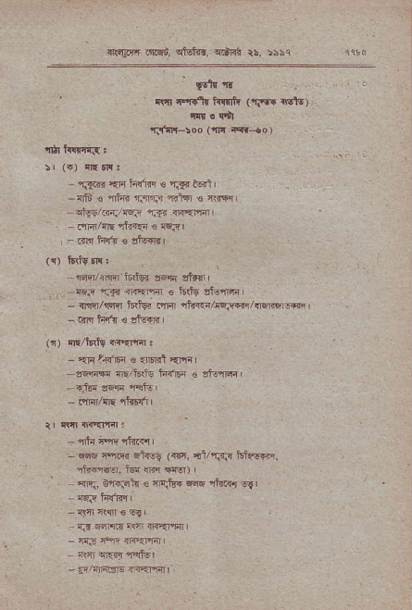
{s&q{ dnd, _{ctul{r.} ^{qffi} ii, 55\q
_{Wlr} !t
^{.w} nnr.lr ffi' _{{Tq} Nl6,
i!|r. rtl
rFn'l-loo (n ^{i<r+o} )
^{- 'laaR '{F} _{hfm €} ^{q{s} lql l
{ii,' € ^{'iltsn rJjlr.q} _{"irl6l} s {sqq
^{qfu9/F./nEF} r.trr iF=r,ff|
⁻ FrrI/riE rtr.{n r cqFr
- Rr.r hr'i € zturl' I
({) ltrls dF:
'@Arn'1r19j ^{e_qn} "tr.r _{{qi f.t4} ^{.r{ffi} Q Fr6 'fslr@,
⁻ nn/iEir l&foi dlrr iE"{r/{€5*/rrlM.:FB, - .{r tsf{ € ,l-eqr
'-, 4/lFfg 1Erq.
⁻ _{4r} ^{l.r31F €} {nrr'l Er'fi
zFl'F {E/i&is ^{i-iF} € 3tulm
- ^{qi@} _{@r} ^{'rq1} '
⁻ i,lm/rE rturl
tr {r.t 448fir :
- rlli {ftqlr.<{
- ^{q@} erf. Etsq (r!{, {l/rf:{ l61nqrrq. ' rlF.l6. iw @ 4trq) |
' - ^{qq,} Be31q e n\b{ saq rf{r{ sEl
^{{\$ *1n €} w
trI _{diir{.r} ^{'rfr} ${Ear'Fr
⁻ 4{iE ff.t{<rf{l
r? 9F4ti.l
, ]'/nnrjE _{{-iErfdll} .
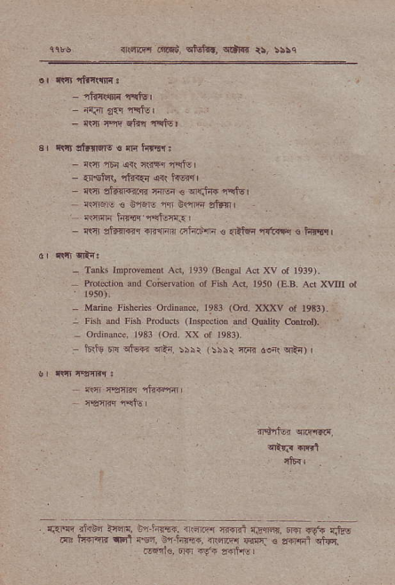
{rqrq'r ..tr6i cftt{.. ^{irdlFd} ts, !55q
⁻ _{rti4ffir} 'r.{lsl
^{- ic} _{!{r} 4dql
⁻ _{it{' Fl'} ^{qiiq} i{tur
a, il.|r ltfirirE € {fi hrr6r:
⁻ {IsF$ {fi5{ a( tsw.r'
ffi' stqrlr{-n _{crEr €} ^{qrj-{T} r!tu|
_{Rffi 3} ^{g'w} _{n} ^{gqFr} si.nl
{stnri hFr nqf.nr3
⁻ elcl stu{.€r {l.{4rn .rl"."',1J{ € _{dic{} ^{'l{RF} € FrEqi
- Tdrs rmprNed.ni Ad, _{,939} ^{(B} _{srt} Act XV ot 1939). Proreriotr d co;dvorioi 0f Fjsb _{Ad, leso} ^{(E.8.} Ad x\,,rlr ot
- Meino lh[eries odinore. 1933 ^{(ft.} XIC<V .t 1933). : ^{Fish ud Fish PrcducE} onsperiod ed omliq cdror), o'.1:nucc' ]e31 _{'old} ^{](\} ol 93])
⁻ _{t6ris 6n} ^{qlw} wii. sbir (5rht lF{ ao( cti{) |
ds rsirri dffi
TsrF Ftur
. _{ram .!30? t{dE} ^{!.'n?-dd.} n cT '6d q,r.@ F 6v.. rj!! ^{m t{.-rr rF. 4.} ! es. ^{-."F,} +@ o F-i" dq

